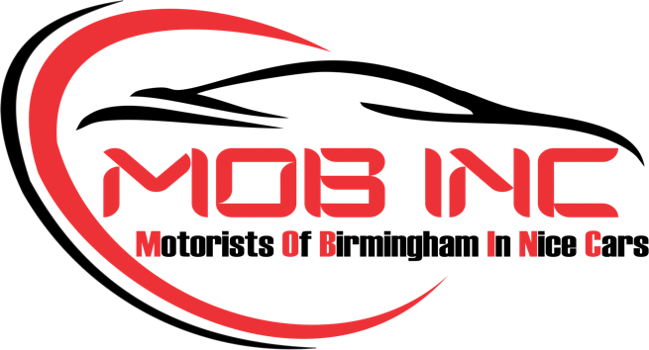

GOLD CORPORATE SPONSORSHIP AGREEMENT

This Sponsorship Agreement, known hereafter as the “Agreement,” is executed on this [DATE] __________ between __________________________, known hereafter as the “Sponsor” and Motorists Of Birmingham In Nice Cars, LLC, known hereafter as “Sponsee.”

Terms of Agreement

- Sponsee Obligations

The Sponsee will give the Sponsor contribution for the following benefits The Sponsee will give the sponsor contribution for the following benefits:

Gold Level - $2500.00 per year

- One (1) reserved booth space at each monthly event.
- Reserved parking spaces at each monthly event.
- Two (2) corporate sponsor polo shirts.
- Physical advertising at each monthly event
- Online advertising on Sponsee social media platform(s) and website reserved each quarter.
- Participation in member events.
- Separate sponsorship opportunities in special community events offered only to MOB INC.

- Sponsee Obligations

The Sponsor agrees to pay the amount of $2,500.00 for level made payable to Sponsee by check, credit card or ACH deposit.

- Sponsor Trademarks and Materials

Subject to the terms and condition of This Agreement, the Sponsor grants, the Sponsee, the right to use the Sponsor’s trade names, logo designs, trademarks, and company descriptions as provided and used in Sponsor’s marketing material. These assets may be used in any medium of advertising, promotional products, or marketing material, distributed, solely and connected with Sponsee. Sponsee agrees to use materials according to Sponsor’s trademark usage guidelines.

The Sponsor agrees to offer the following material for marketing and promotional purposes:

- Company logo (vector or .PNG format)
- Company description
- Company contact information
- Indemnity

A. The Sponsor will indemnify, defend, and hold the Sponsee harmless from and against any and all liability, claims relating directly or indirectly to, or arising out of content posted on the Sponsee’s, or Sponsor’s respective websites, use of Sponsor’s material, or use of Sponsor’s logo, and trademark.

B. The Sponsee will not be responsible, and the Sponsor agrees to indemnify, defend, and hold harmless Sponsee from and against any and all claims relating directly or indirectly to damages or loss of property belonging to the Sponsor, it’s employees, contractors, agents, directors, or invitees. The Sponsee will not be responsible, and the Sponsor agrees to indemnify, defend, and hold harmless Sponsee from and against any and all claims relating directly or indirectly to damages, injury or loss related to injuries to the Sponsor’s employees, contractors, agents, directors, or invitees, except to the extent that claims may be solely indirectly attributed to the willful misconduct of the Sponsee and Sponsee’s employees, directors, or officers.

C. The Sponsor shall give Sponsee immediate written notice of any lawsuit or claim that are covered or potentially covered by this indemnification provision.

- Limitation of Liability

Under no circumstances shall either party be held liable to the other party for damages whether consequential, incidental, indirect, or punitive damages, irrespective of whether such liability arises from breach of contract, breach of warranties, tort, strict liability, or any other legal theory.

- Term and Termination

- This agreement will be valid for the period of 1 year from payment via stripe or check.

B. Sponsee may terminate this agreement with Sponsor at any time for any reason. In the event that the Sponsee terminates this Agreement for any reason, other than Sponsor’s breach of this agreement or Sponsor’s breach of the code of conduct, the Sponsee shall refund a prorated amount of the sponsorship fees received from the Sponsor and return any materials, equipment, hardware, or software, loaned by the Sponsor for the event, at the Sponsor’s expense.

C. Sponsor Agrees to abide by and enforce the code of conduct with respect to Sponsor’s employees, contractors, agents, directors, and invitees.
D. The Sponsor may terminate this Agreement for breach of agreement by the Sponsee, after giving Sponsee at least ten (10) days prior written notice, specifying the nature of the breach, and giving these Sponsee at least ten (10) days to cure such breach. If the breach occurs less than 10 days before the event, Sponsor may terminate this agreement if breach is not cured by the first day of the event.

- Arbitration Clause

A. Any dispute, controversy, or claim arising out of or relating to this agreement, including its formation, interpretation, breach, termination, or validity, shall be exclusively settled by the American Arbitration Association (AAA) administered by in accordance with its rules.

B. The parties hereby waive any right to a trial by jury in any action or proceeding arising out of or relating to this agreement.

C. The parties agree that any award rendered by the arbitrator(s) shall be final and binding upon them, and judgment upon the award may be entered in any court having jurisdiction thereof.

D. The parties shall equally share the costs of the arbitration, including the fees of the arbitrator(s).

E. All arbitration proceedings, including any awards, shall be kept confidential, except as may be necessary to enforce an award or as otherwise required by law.

- Miscellaneous

A. This agreement constitutes the entire understanding and agreement between the Sponsor and Sponsee with respect to the subject matter hereof and supersedes all prior and contemporaneous agreements, representations, warranties, and understandings, whether oral or written. No modification, amendment, or waiver of any provision of this agreement shall be effective unless in writing and signed by both parties.

B. This Agreement, including Arbitration, shall be governed by and construed in accordance with the laws of Alabama.

C. The content, terms and conditions contained in this agreement are confidential and shall not be divulged to any third party without written approval from both parties.

In witness whereof, the Sponsee and Sponsor hereby agree to enter into this Agreement on the day and year contained above by affixing their respective signatures below.

Sponsor

Name: ________________________________

Title: _________________________________

Sponsee

Name: ________________________________

Title: __________________________________

Payment Information

To pay by card or ACH:

Please visit: www.mobincbhm.com
Follow the Sponsorship tab to be guided to the payment page. Please return signed forms in PDF format to Info@mobincbhm.com

To pay by Check:

Make Checks Payable to MOB INC and include this signed form and submit by mail to the following address:

MOB INC
6052 Brookhill Circle
Birmingham, AL. 35242

