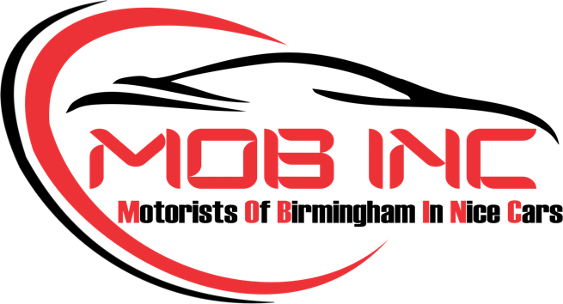

INDIVIDUAL SPONSORSHIP AGREEMENT

This Sponsorship Agreement [known hereafter as the "Agreement"] is executed on this [Date]___________ between __________________________________________ , known hereafter as the "Sponsor"] and Motorists Of Birmingham In Nice Cars, LLC., known hereafter as the "Sponsee."
Terms of Agreement
1. Sponsee Obligations
The Sponsee will give the Sponsor contribution for the following benefits:
- One (1) reserved parking spaces at each monthly event
- One (1) individual sponsor polo shirt
2. Sponsor Obligations
The Sponsor agrees to pay the amount of $200 made payable to Sponsee and due by March 31, 2024.
3. Limitation of Liability
In no event shall either party be liable to the other party for any consequential, incidental, indirect, or punitive damages regardless of whether such liability results from breach of contract, breach of warranties, tort, strict liability, or otherwise.
4. Term and Termination
4.1 This Agreement will be valid for the period of April 1, 2024 to March 31, 2025.
4.2 The Sponsee may terminate this Agreement at any time for any reason. In the event that the Sponsee terminates this Agreement for any reason other than Sponsor's breach of Agreement, the Sponsee shall refund any fees received from the Sponsor and return any materials, equipment, hardware, or software loaned by the Sponsor for the event, at the Sponsor's expense.
4.3 The Sponsor may terminate this Agreement for breach of Agreement by the Sponsee after giving Sponsee at least ten (10) days prior written notice specifying the nature of the breach and giving the Sponsee at least ten (10) days to resolve such breach. If breach occurs less than ten (10) days before the event, Sponsor may terminate this Agreement if breach is not resolved by the first day of the event.
5. Disagreement
In the case of a disagreement at any point, the parties will refer the matter to an independent arbitrator appointed by mutual agreement.
6. Miscellaneous
6.1 This Agreement will supersede any or all prior oral or written forms of understanding between the Sponsor and Sponsee. This Agreement may not be amended or modified except when one or both parties execute amendments in writing and amendments are signed by both parties.
6.2 This Agreement shall be governed by and executed in accordance with the laws of the State of Alabama applicable to agreements made and to be performed entirely within this state.
6.3 The terms and conditions of this Agreement shall not be divulged to any third party without prior written approval from both parties.
In witness whereof, the Sponsee and Sponsor hereby agree to enter into this Agreement on the day and year first written above by affixing their respective signatures below.

Sponsor

Name: ________________________________

Title: _________________________________

Sponsee

Name: ________________________________

Title: __________________________________

Payment Information

To pay by card:

Please visit: www.mobincbhm.com
Follow the membership tab to be guided to the payment page. Please return signed forms in PDF format to Info@mobincbhm.com

To pay by Venmo:

Please follow the QR code provided below and complete payment information. Submit signed form in PDF format to info@mobincbhm.com

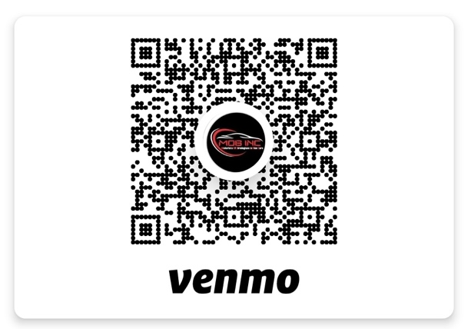

To pay by Check:

Make Checks Payable to MOB, INC and include this signed form and submit by mail to the following address:

MOB, INC
P.O. Box 531195
Mountainbrook, AL 35253-1195

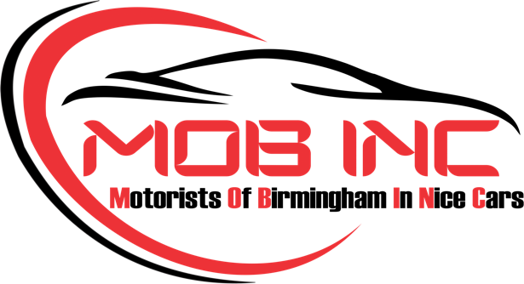

CODE OF CONDUCT AND LIABILITY RELEASE

CODE OF CONDUCT
This code is to provide the requirements, expectations, and principles which Members of MOB, INC (Club) will be responsible for observing when participating in events conducted by the Club. These requirements shalt always apply while at Club events, traveling to or from events, and all other times when representing the role as a member of the Club.

- Members are to operate within the rules and spirit of the Club agreeing to abide by the rules of the Club and should always respect the individuals administering the rules.
- All members are reminded that when participating in any of the Club's activities, they are representing the Club itself and should do always so with a favorable reflection and consider all actions to ensure no detriment to the Club or its reputation.
- Members are advised to adhere to all legal, road, and social rules and agree to abide by all local, state, and federal laws, and agree to be held responsible for their actions.
- Members agree to respect the rights, dignity, and worth of every person with whom they have contact regardless of age, gender, religion, sexual orientation, ethnic origin, or ability, and agree to accept responsibility for their actions and display high standards in language, conduct, punctuality, and presentation.
- Members are to refrain from any form of verbal, physical or emotional abuse toward other members, or any other person, with whom they have contact Members should also refrain from making derogatory comments pertaining to any and all other car clubs.
- At any time while wearing the Club logo, members are representative of the Club, and their actions should reflect positively upon the Club. Always consider the consequences of your actions.
- Members shall not, under any circumstances, undertake any activity in the name of the Club without consideration and approval of the officers.

ONLINE SOCIAL MEDIA CONDUCT
The Club respects the rights of our members to use blogs and other social media tools. It is important that all members are aware of the implications of engaging in forms of social media and online conversations that reference the Club, or its members. There is a difference in speaking on behalf of the Club and in speaking about the Club.
The following principles refer to those personal or unofficial online activities where you might refer to the Club, be it during or outside of a Club event or social activity.

  - Always adhere to the general Code of Conduct regarding respect privacy. discrimination, harassment, and confidentiality.

  - Avoid foul language and profanity, including words with missing letters or substitutions such as asterisks or dashes,
  - Abuse, insults, and personal attacks directed at other people, sponsors, corporations, or products are unacceptable. No debate - no negative statements directed towards another person, company or product no posts meant to offend or hurt any other member, no racial, ethnic, gender-based insults or any other personal discriminations.
  - Finally, remember that the internet is permanent, even if you "remove/delete later, or attempt to make it anonymous. In the end, you are responsible for your actions.

TIRE SPINNING of ANY FORM is STRICTLY PROHIBITED!
If you BURN OUT, YOU ARE OUT!

It is the intention of the Club to provide social, and automotive events for its members, guests, and hosts. By virtue of their membership, members agree to demonstrate personal responsibility for their words, actions, and deeds, and not to exhibit behaviors that are harmful or detrimental to themselves or other members, guests and hosts, or their personal property.
The mission of the Club is to utilize our love of cars to impact the lives of others through community events that foster philanthropy, fellowship, mentorship, and leadership. The Club will not condone behavior contrary to our objectives, nor that which we feel is harmful or injurious to others. Members not adhering to the goals and principles outlined in this Code of Conduct may have their membership revoked.

By joining the Club, I/we agree to and intend to abide by the principles and rules set forth above. Should my/our membership be revoked, I/we also agree to forfeit any paid dues.

LIABILITY RELEASE By joining Motorists Of Birmingham In Nice Cars, LLC., I/we hereby for myself, my heirs, and personal representatives, assume any and all risks associated with any Motorists Of Birmingham In Nice Cars, LLC. hereafter called the "Club", events that I/we attend. I/we further waive, release, discharge, and pledge not to sue the Club, its officers, members, sponsors, organizers, or other representatives or successors, for any injuries or damage of any kind whatsoever, as a result of being a member of the Club, or of taking part in Club events and related activities.

X
Signature

X_____________________
Date

